## **Tennis Warm Up**

Here are 5 steps to achieve an effective **tennis warm-up**, which should take you around 10-15 minutes to complete.

Perfect Timing- Allocate 10-15 minutes to complete your tennis warm-up and then allow that same period of time for a breather before you step on the court.

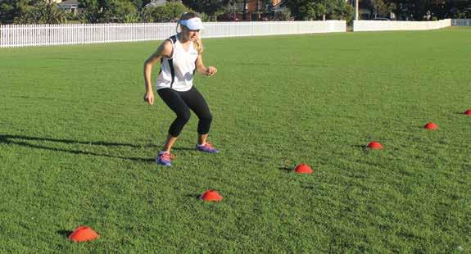

**1. CARDIO**

3-5 minutes of either skipping or running (forward, backward, and lateral) is the perfect way to start your tennis warm-up. Remember the aim is to boost your heart rate and circulation, so increase the intensity with each minute. We really encourage all our players to skip. Skipping is a great activity to incorporate, especially for tennis players, who need coordinated arm and leg movement, as well as helps keep you on your toes, right from the start. Steffi Graf was a great advocate for skipping.

It's a minimum fuss too. You simply need a rope and a small space. Skipping is a lower impact than running - so there's less risk of injury. Even so, it's a good idea to protect your joints by choosing softer surfaces where possible. Keep the rope in your bag but it's better to skip off the court.

Skipping tips - Some other tips that will help you get the most from skipping: - Stand straight, without leaning forward as you skip. - Keep elbows at waist level, tucked as tightly as possible. - Your skipping rope should be taught. - Skip fast enough for your rope not to become tangled. - Jump on the balls of your feet and land softly.

**2. THE RANGE OF MOVEMENT (ROM)**

These exercises are a great way to mobilize joints and lengthen muscles throughout the body. ROM exercises can be seen as an active stretch or loosening up of the body. The beauty of ROM [**tennis exercises**](https://www.tennisfitness.com/tennis-exercises) is they open up the "chain of movement" rather than isolating a specific area or muscle. This is important to do before participating in any sport but especially so in tennis, given the multi-directional ranges and loading patterns.

**3. STRETCHING OR FOAM ROLLING**

You may find some problem areas that get a little tight, that need to be released or lengthen prior to exercises. Implementing some simple foam roller exercises and [stretches for tennis](https://www.tennisfitness.com/blog/tennis-cool-down-routine), can all help elongate muscles and open joints up for correct movement patterns. To avoid any injuries it is imperative you have a good range of motion throughout all joints, as this will help with creating power throughout your shots. E.g limited thoracic rotation may inhibit your rotation on your forehand, which adversely can cause over-whipping with the arm to generate power.

**4. MUSCLE ACTIVATION**

Activating muscles works by stimulating specific muscles and waking them up prior to your match or [tennis training session](https://www.memberstennisfitness.com/). Most people have muscle imbalances or potential instability issues around certain joints, so it is important to stimulate the correct muscles and encourage them to work. Some players may look at activating their core or gluteals, whilst others will look at performing some rotator cuff resistance band exercises. It’s great to have your own routine that you know works for you.

**Wake Up!** Don't confuse muscle activation with muscle fatigue-the the activation works by stimulating the muscle and not tiring it out before your ***exercise for tennis.***

**5. SHADOWING**

This is the final phase of the ***tennis warm-up*** sequence. Shadowing mimics, the movements that would be performed on the court. It will fire up both your nervous system and your body by following specific tennis movement patterns. Perform tennis shadowing for three minutes, alternating between forehands, backhands, overhead or smash, and volleys. These shadowing [exercises for tennis](https://www.tennisfitness.com/strength-and-conditioning) can also be used to help prepare mentally before you play. The intensity of the shadowing should increase with each minute, so by the time you have finished you are not only physically prepared but also mentally ready for the first point when you step onto the court. Rafael Nadal is a great advocate for shadowing prior to his match.